DME Unified Browse Design
  - Design Document
Version 1.0
7/21/2025

Version History

Version Number | Implemented By | Revision Date | Approved By | Approval Date | Description of Change
1.0 | Yuri Dinh |  |  |  | Initial Draft

Table of Contents
Version History 2
1 Introduction 4
1.1 Purpose of this document 4
1.2 Background 4
1.3 Scope 4
1.4 Assumptions and Constraints 5
2 Database Design 6
2.1 Table Design 6
3 Software Design 6
3.1 High Level Design 6
3.2 Detailed Design 7
3.2.1 API Design 7
3.2.2 UI Design 10

Introduction

Purpose of this document
The purpose of this document is to record the detailed design of a subset of requirements from the Auto tiering capability from VAST Storage to DME (AWS Glacier Deep Archive). This capability enables auto-archival of the files that are not accessed over a configured period.
The design document contains detailed design for a subset of this capability, which is to enable the users to view their files/folders in VAST as well as the files auto-tiered to AWS Glacier Deep Archive through DME in a unified view.

Background
Currently the users are storing data into NCI VAST Storage directly or through Biowulf into VAST. There is a need to manage the lifecycle of these files/folders as the data grows, and to automatically tier these files to AWS Glacier Deep Archive if they are not being accessed by the user for some period. DME already has the capability to archive/migrate DME managed files to AWS Glacier Deep Archive and this capability will be extended to automatically move files/folders that are in VAST Storage and preconfigured as DME managed space to AWS Glacier Deep Archive.

Scope
We have identified three high level requirements to support this feature.
- Provide a view to the configured VAST storage space from DME. The view shall be a unified view that shows both the files in VAST as well as the files tiered to Glacier and include the ability to calculate the size of these folders.
- The user shall be able to download files from DME as well as from the VAST storage from the unified view.
- The files that are not accessed for a configured amount of time shall be automatically tiered to Glacier deep archive by a new DME scheduler task.
- Enhance the download API to add capability to download VAST files that are not archived to DME but exists in the configured space.
The scope of this document is to record the detailed design of 1).

Assumptions and Constraints
The DME hierarchy will match that of the file structure in VAST. User metadata will not be captured. The VAST Storage will be mounted on the DME servers. User permissions will be pre-configured based on the owner permissions of the file system.

Database Design

Table Design
The configuration of the hybrid DME Archive which consists of a combination of VAST files and DME managed Glacier files will have the following configuration.
In HPC_DATA_MANAGEMENT_CONFIGURATION table, the new archive will be setup as an S3 archive. The S3 Upload Archive Configuration ID will be used to link the external storage configuration used and the Get Data Management Model API will be modified to return the POSIX path of each base path which has an external archive configuration configured via the HpcDataManagementRulesDTO.
For example,
BASE_PATH | DOC | S3_UPLOAD_ARCHIVE_CONFIGURATION_ID
/TEST_EXT_Archive | DME_TEAM

In S3_ARCHIVE_CONFIGURATION table, two new columns, external_storage and posix_path has been added to support the hybrid archive.
PROVIDER | BUCKET | EXTERNAL_STORAGE | POSIX_PATH
VAST | dme-dev-bucket-vst | 1 | /mnt/DMETemp/test_auto_tiering
AWS | dme-devp-bucket | 0

Software Design

High Level Design
To provide a unified view of the configured VAST storage space from DME that shows both the files in VAST as well as the files tiered to Glacier, here are the high-level design.
- Adding a page in DME to display directories and files – created date, modified date and size (for files only)
  - There are 4 possibilities – VAST directory, DME directory, Mixed (Directory containing sub-directories in VAST and DME). We should not have the case where a directory is in both DME and VAST, because when we create a directory in DME we delete it from VAST.
  - We will show this is a separate browse screen, different from the current DME browse (legacy) screen.
- Adding a new API to get directory listings with permission
- Adding a new API to calculate the size of a directory (can expand to a set of directories in a later phase).

Detailed Design

API Design

New Browse API to get directory listings

GET /listObjects/{external path}
The API will list the subfolders and files of this directory in VAST as well as the child collection and data objects in DME that the requesting user has access to.
External Path – The full path of the directory listing to be obtained. (This is the VAST storage path, and the DME path will be derived from the configuration.) If the path does not map to any of the configured S3 external configuration path, the request shall be rejected.
The API will filter the listing results based on either the iRODS permission of the requesting user to this directory or based on the POSIX file attribute owner.
Archived attribute – false if DME record doesn’t exist (external only or archive link), true if otherwise (DME managed record)
For SYTEM_ADMIN, we do not filter based on the VAST owner permission.
Response:
{
"listObjectsResult ": {
"name": "CMM",
"path": "/data/CMM",
"archivePath": "/CCR_CMM_Archive",
"totalRecords": 7,
"contents": [
{
"name": "PI_0002",
"path": "/data/CMM/PI_0002",
"archivePath": "/CCR_CMM_Archive/PI_0002",
"created": "2021-05-21 15:18:46",
"lastModified": "2022-04-29 13:28:49",
"isDirectory": true,
"archived": true,
"size": ""
},
{
"name": "PI_0003",
"path": "/data/CMM/PI_0003",
"archivePath": " /CCR_CMM_Archive/PI_0003",
"created": "2021-06-17 12:26:56",
"lastModified": "2024-12-16 13:40:16",
"isDirectory": true,
"archived": false,
"size": ""
}
{
"name": "tilt1.tar",
"path": "/data/CMM/tilt1.tar",
"archivePath": "/CCR_CMM_Archive/tilt1.tar",
"created": "2021-05-21 15:18:46",
"lastModified": "2022-04-29 13:28:49",
"isDirectory": false,
"archived": true,
"size": 170183323136
},
{
"name": "tilt2.tar",
"path": "/data/CMM/tilt2.tar",
"archivePath": " CCR_CMM_Archive/tilt2.tar",
"created": "2021-06-17 12:26:56",
"lastModified": "2024-12-16 13:40:16",
"isDirectory": false,
"archived": false,
"size": 5432321024
},
{
"name": "tilt3.tar",
"path": "/data/CMM/tilt3.tar",
"archivePath": "/CCR_CMM_Archive/tilt3.tar",
"created": "2021-06-14 15:08:04",
"lastModified": "2021-06-23 15:36:11",
"isDirectory": false,
"archived": true,
"size": ""
},
{
"name": "tilt4.tar",
"path": "/data/CMM/tilt4.tar",
"archivePath": "/CCR_CMM_Archive/tilt4.tar",
"created": "2021-06-14 15:39:21",
"lastModified": "2024-12-16 13:40:16",
"isDirectory": false,
"archived": true,
"size": 43788804096
},
{
"name": "tilt5.tar",
"path": "/data/CMM/tilt5.tar",
"archivePath": ""/CCR_CMM_Archive/tilt5.tar",
"created": "2021-06-14 15:39:21",
"lastModified": "2025-02-03 14:05:28",
"isDirectory": false,
"archived": false,
"size": 348228927618
}
]
}
}

New API to calculate the size of a directory

POST /calculateTotalSize – If we need to specify multiple folders in the future, better to specify path in request body.
The API will calculate the total size of the specified path.
Path – The full path of the directory to calculate the total size. (This is the VAST storage path, and the DME path will be derived from the configuration.) If the path does not map to any of the configured S3 external configuration path, the request shall be rejected.
If user has access to the specified external path, the paths could be path from different base paths.
includeArchive - Include total size calculated for VAST as well as DME.

Request:
{
"paths" : [
"/data/CMM/PI_0002",
"/data/CMM/PI_0003"
],
"includeArchived" : true
}

Response:
{
"calculateTotalSizeResult" : [
{
"path": "/data/CMM/PI_0002",
"archivePath": "/CCR_CMM_Archive/PI_0002",
"objectCount": 5,
"size": 348228927618,
"archiveCount": 4,
"archiveSize": 228927618321
},
{
"path": "/data/CMM/PI_0003",
"archivePath": "/CCR_CMM_Archive/PI_0003",
"objectCount": 2
"size": 43788804096,
"archiveCount": 3,
"archiveSize": 21182289556
}
]
}

UI Design

The following new screen will be created under the Browse Tab.
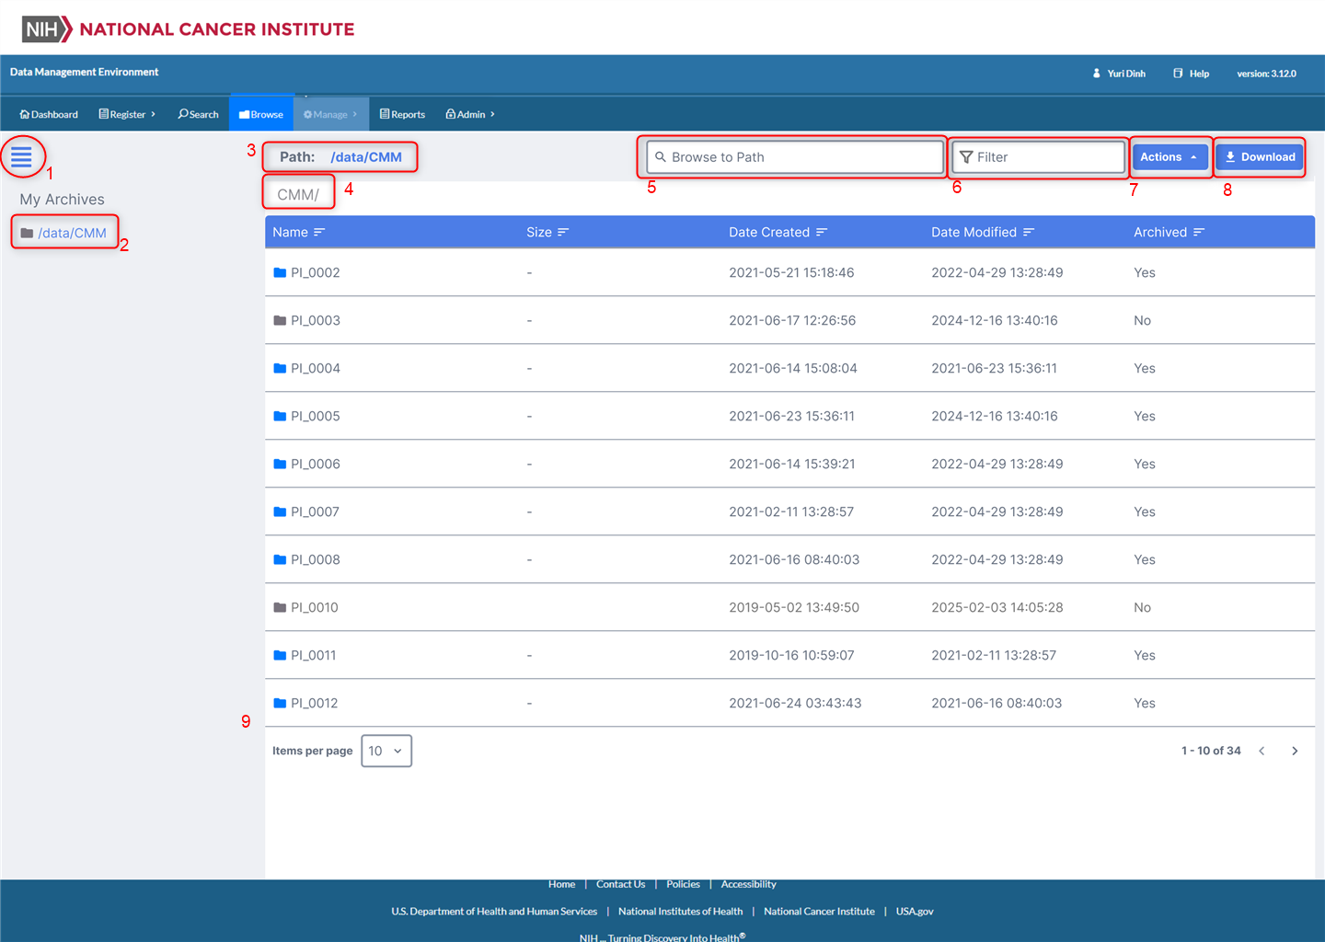
- Clicking the menu/hamburger icon will display the left side bar if collapsed, hide the left side bar if expanded.
- The list of DME managed external VAST folders
- The full path of the current directory which is displayed is shown
- The directory name of the current directory which is displayed is shown
- If the user knows the full path of the directory to be listed, they can enter the full path and click enter
- If the user types a key word, the table will filter the rows which contains the key word.
- The user will select a row (single select only) in the table to perform one of the following actions.
  - Copy Path
  - Calculate Total Size
- The user will select a row (single select only) in the table to perform a download of a collection of files.
- The table will display the contents of the directory in the following fashion:
  - Columns:
    - Name (name of the folder/file)
    - Size (size of a file, size will not be available for folders)
    - Date Created (Creation date time of the file or folder)
    - Date Modified (Modified date time of the file or folder)
    - Archived - For folders that only exists in VAST and not yet archived to DME, it will display No. For files that are archived to DME, it will display Yes.
  - Folder icons will be displayed next to folders.
  - Items per page will be displayed and will be configured with an appropriate page size setting. (TBD)
  - Page navigation will be displayed to navigate between pages and to display the total number of objects in the directory.

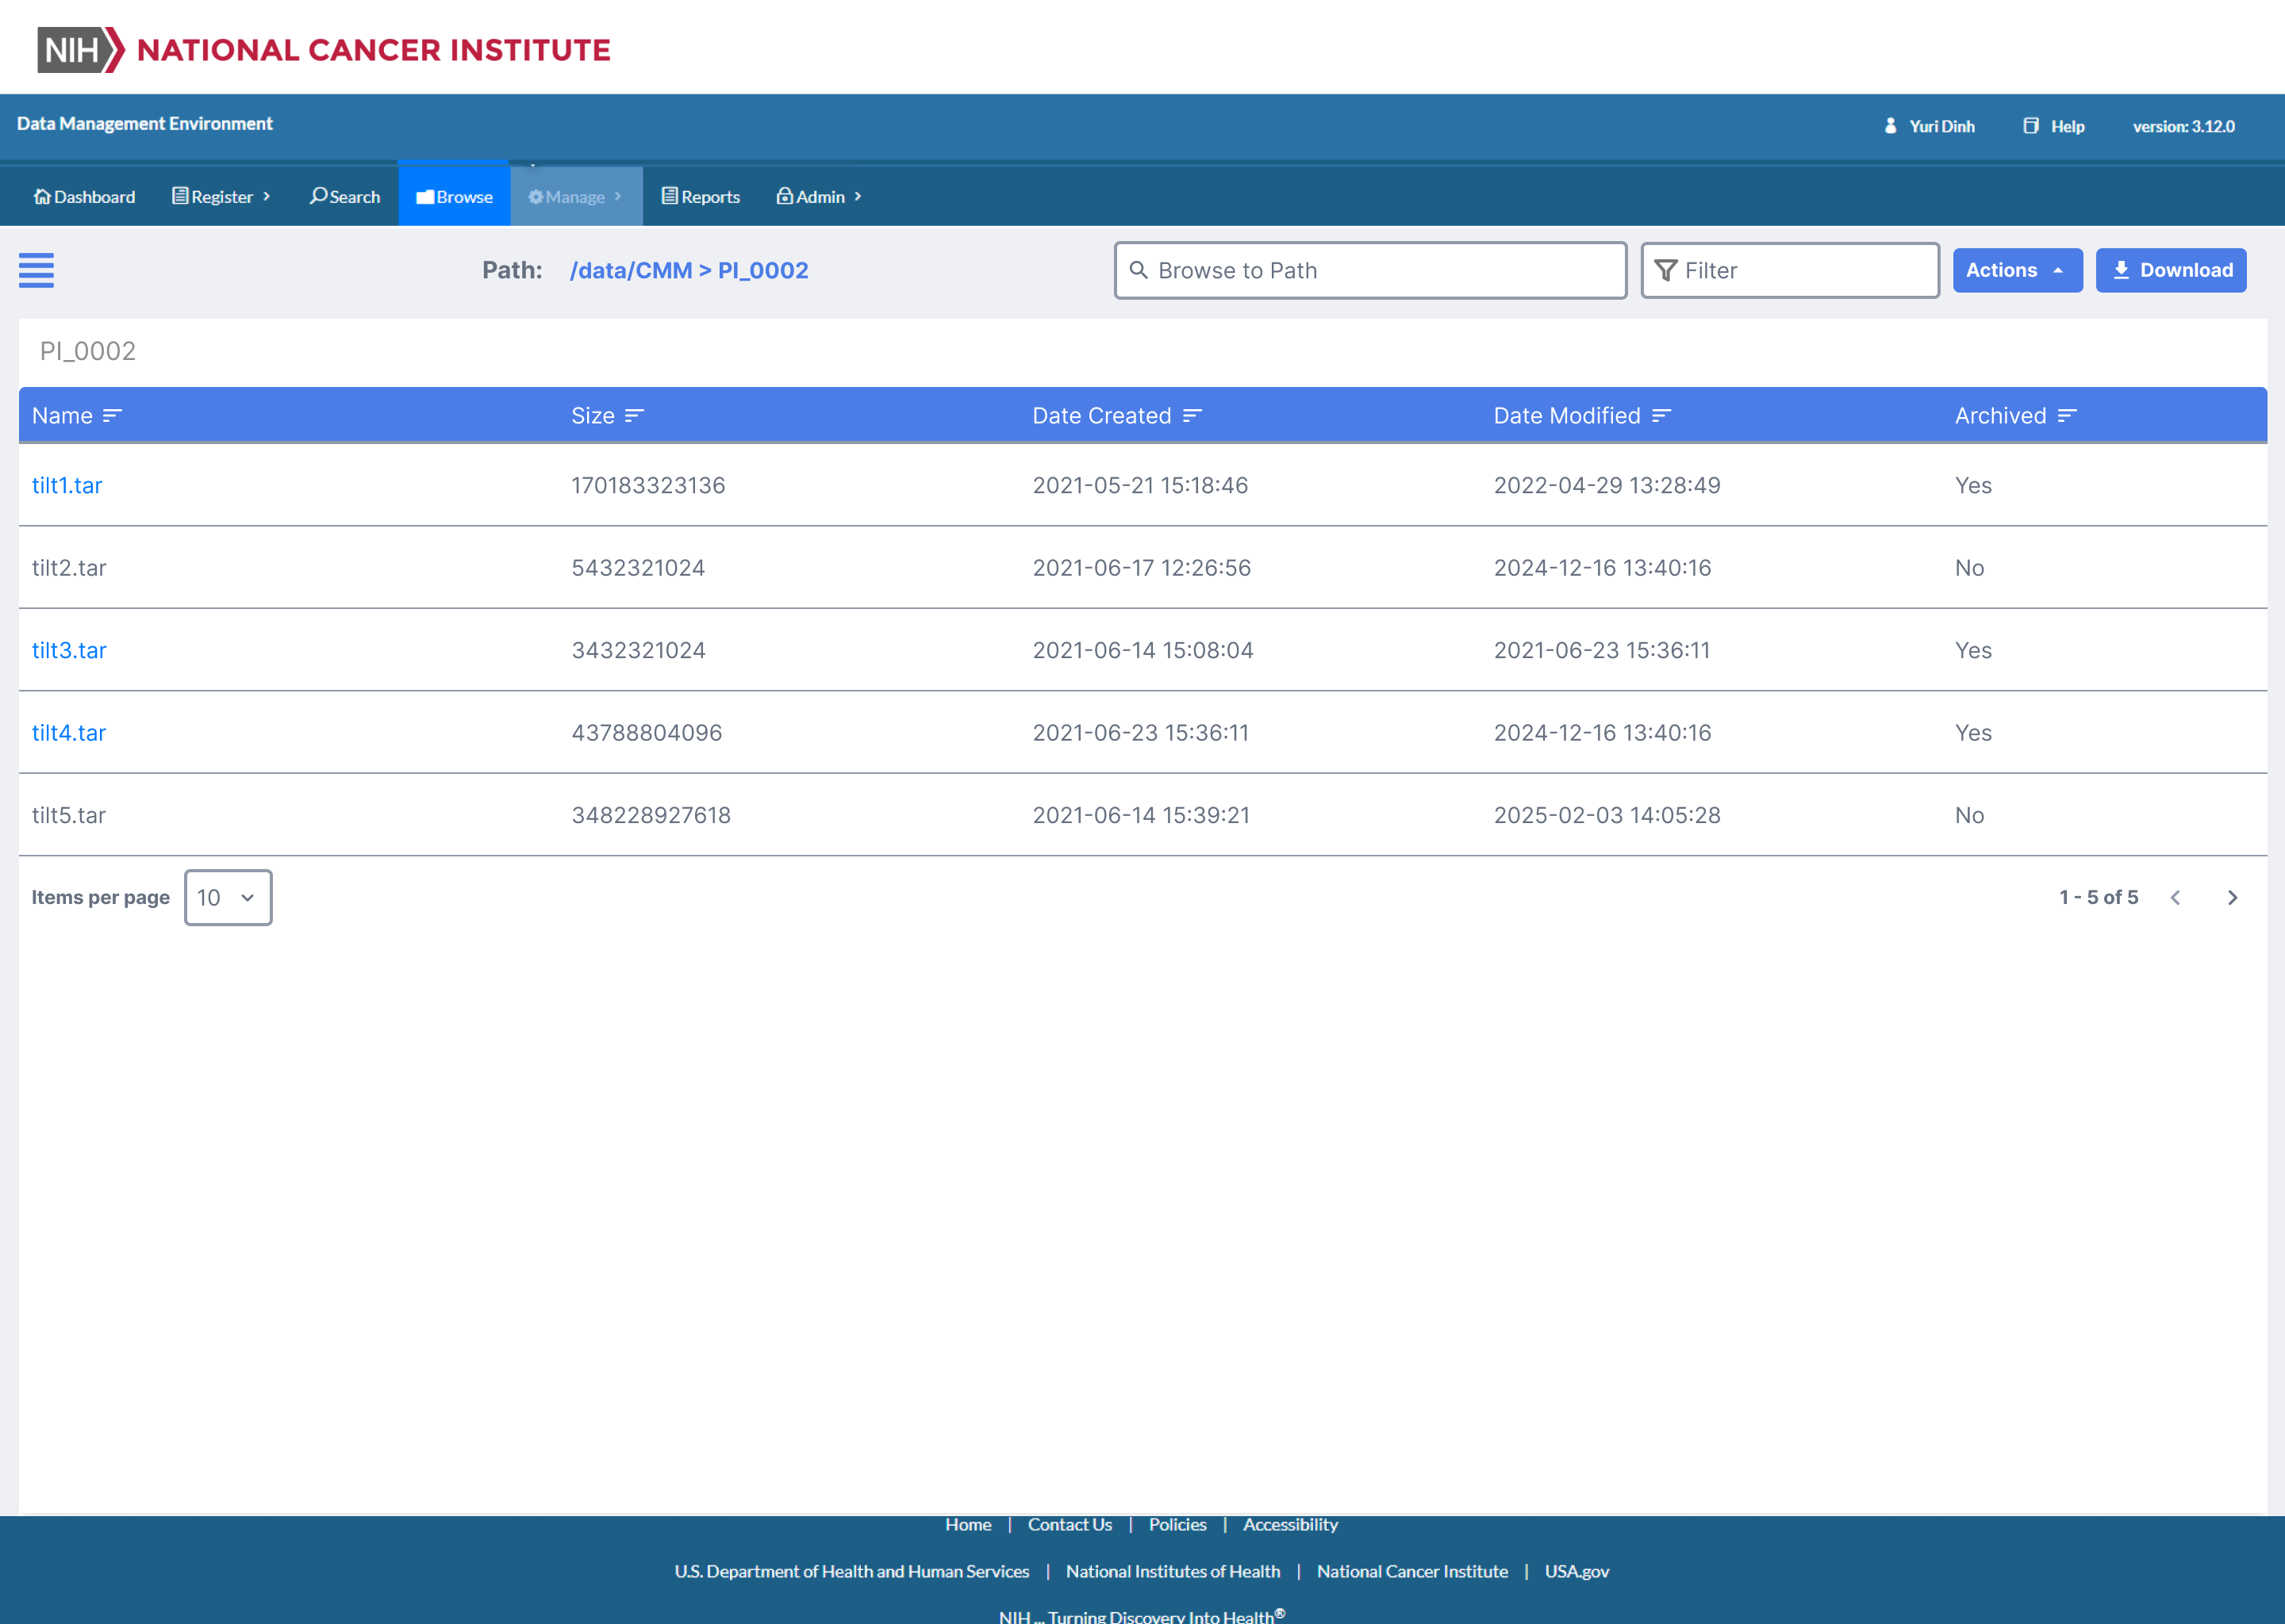

When the user selects a row and clicks on the Calculate Total Size from the Action button, they will be taken to the following new page to display the size of the folder.
